NAME : NISHITA MANHARSINH SOLANKI

ROLL NO.: 22BCE211

BATCH : D-1

SUBJECT : DEVOPS AND CLOUD NATIVE ARCHITECTURE

**AIM: Develop two RESTful microservices using Spring Boot (Java) and Node.js (JavaScript).**

**Steps: -**

1. **Check version of node**
2. **npm init -y**
3. **npm install express**
4. **npm install -- save-dev nodemon**
5. **"scripts": {"start": "nodemon start",}**
6. **npm start**
7. **create a basic app.js with GET method**

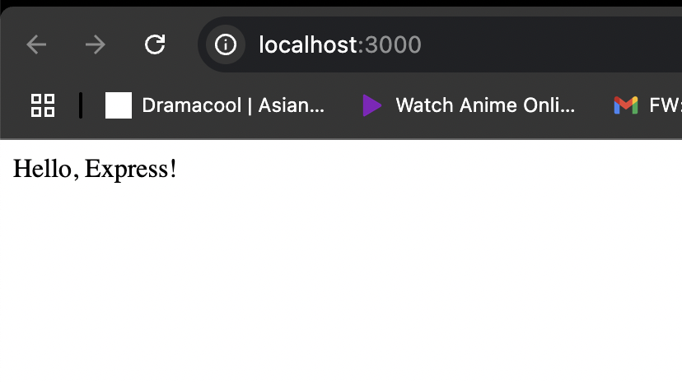

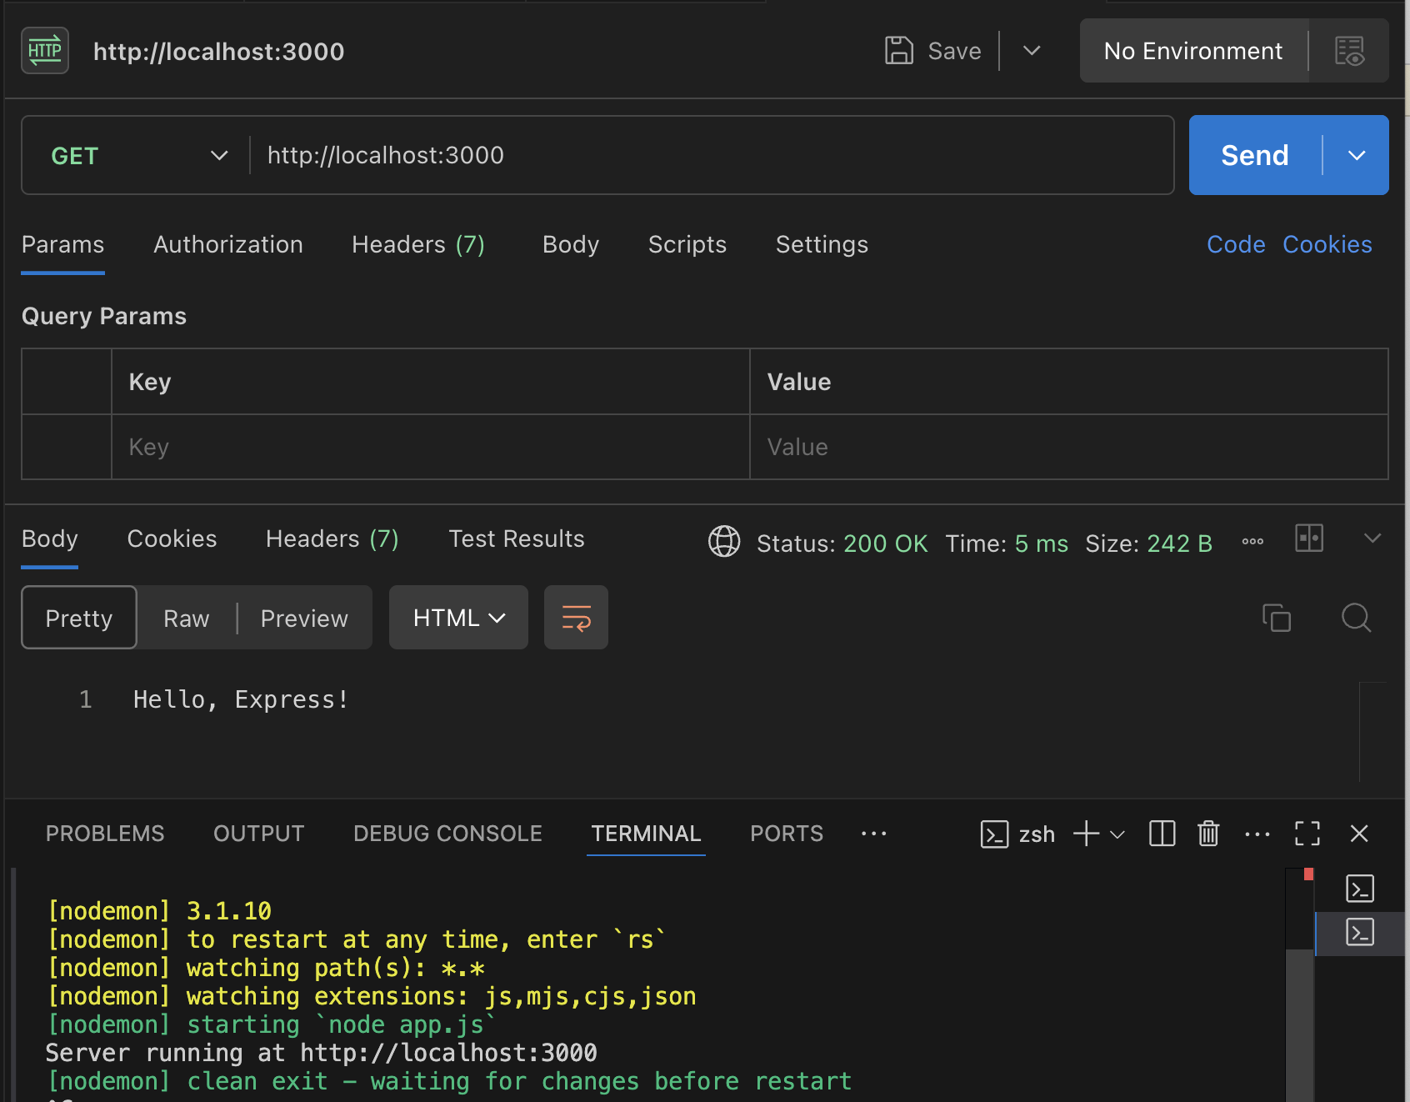

**8)Post method to create a new user /users**

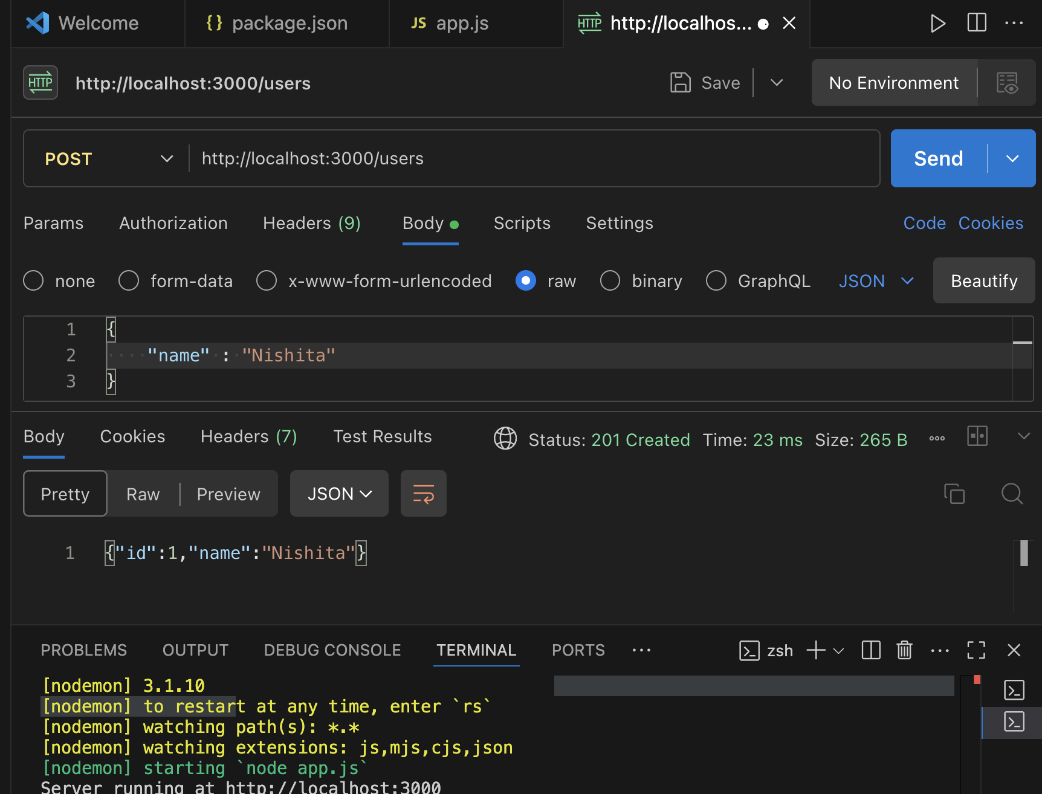

**9)Get method to retrieve the users created**

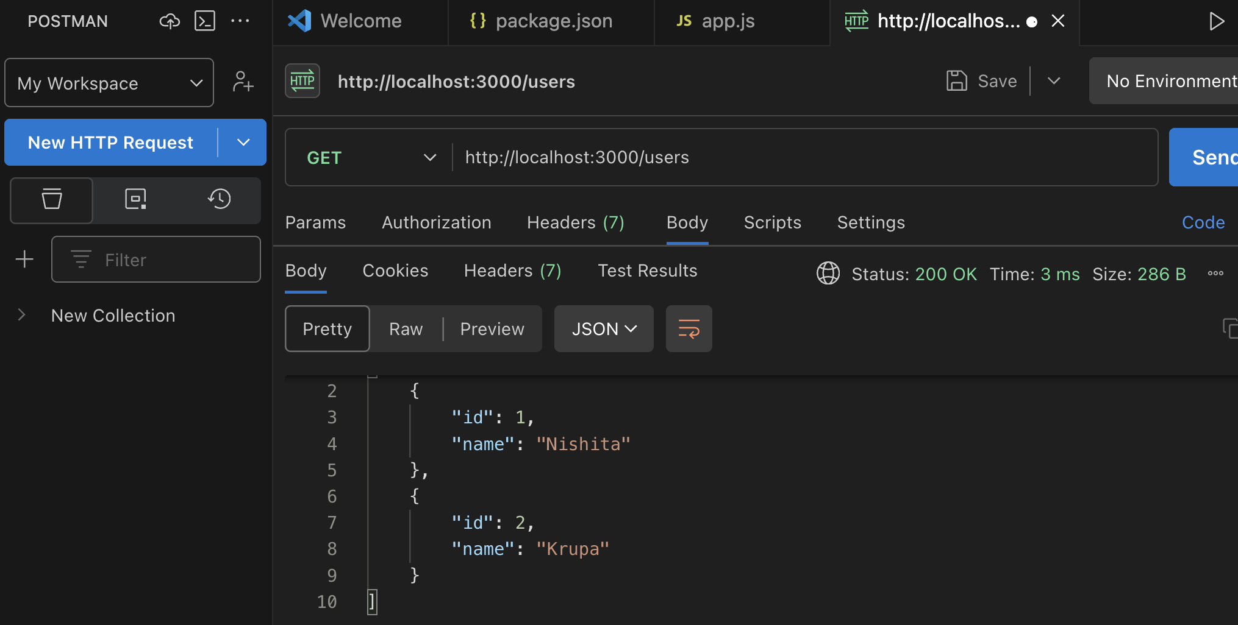

**10) POST method to create a post.**

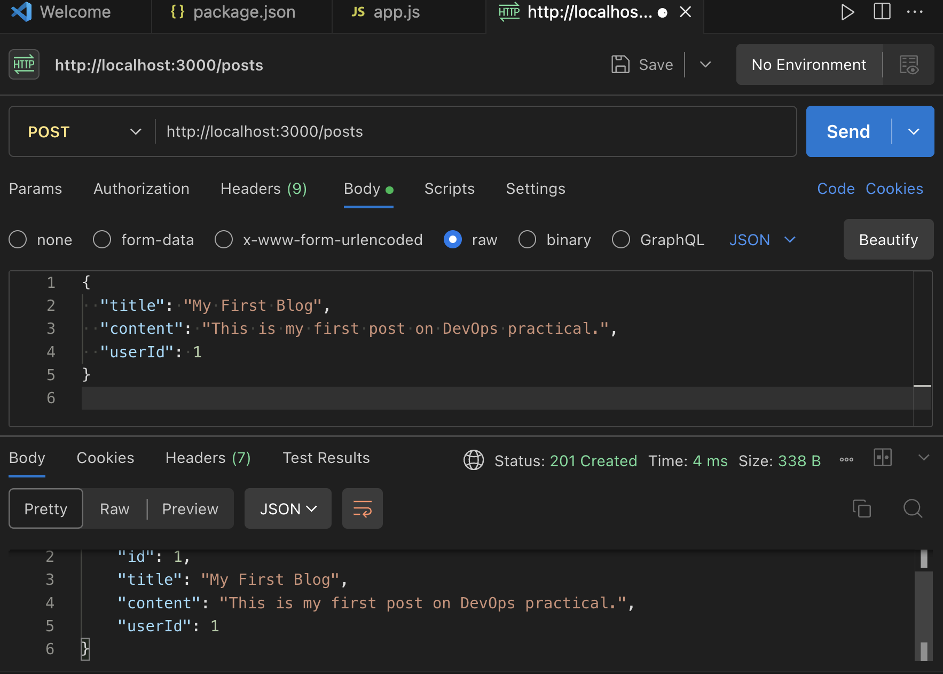

**11)GET method to get the post**

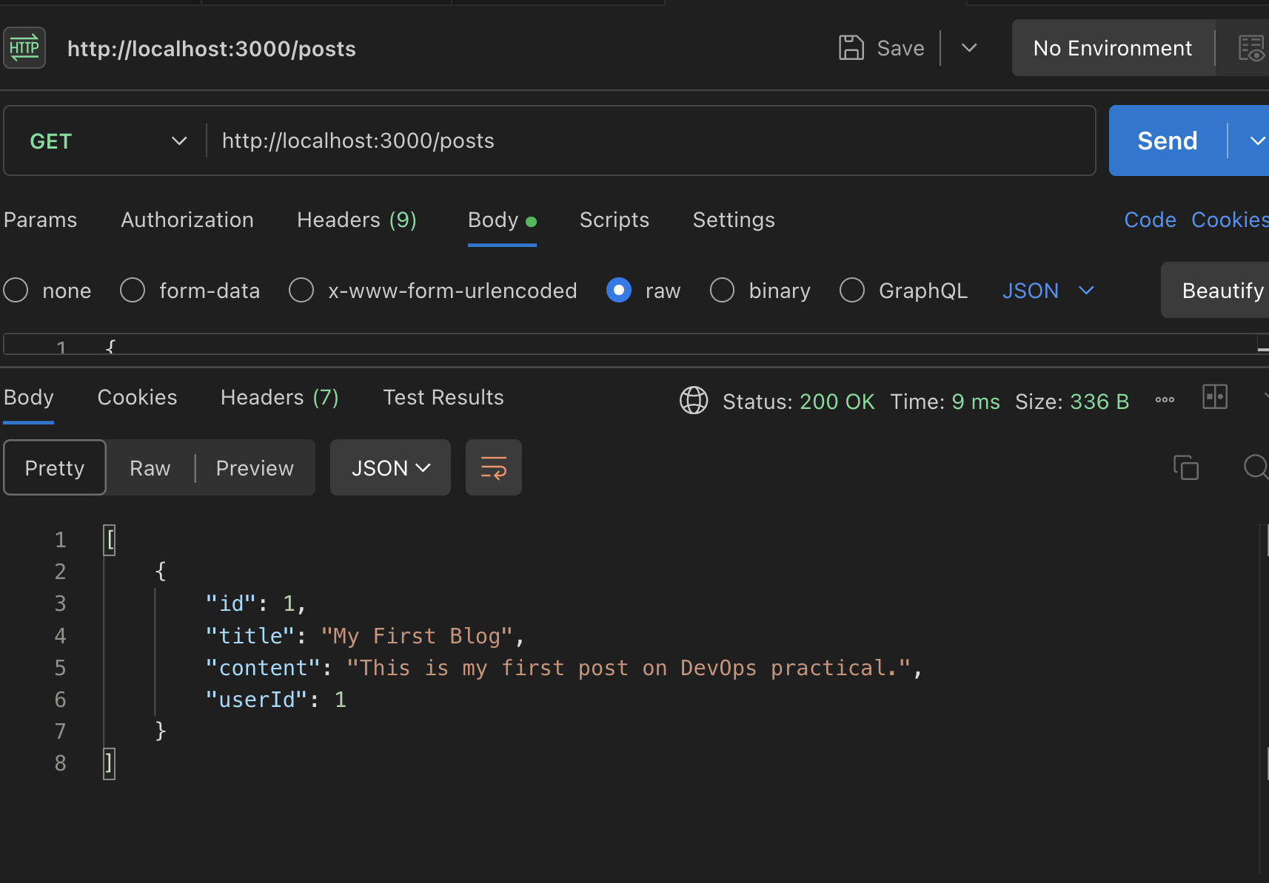

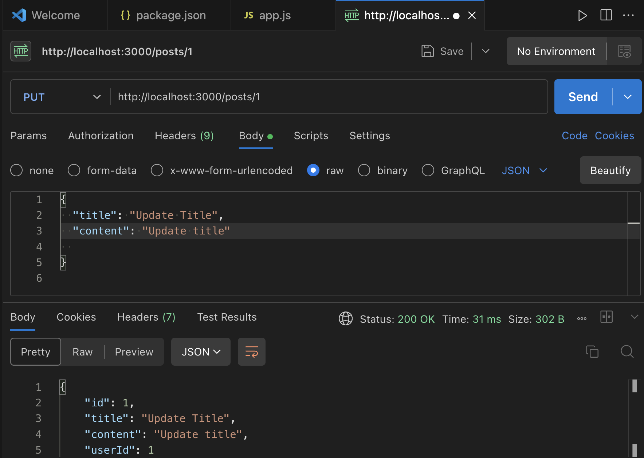

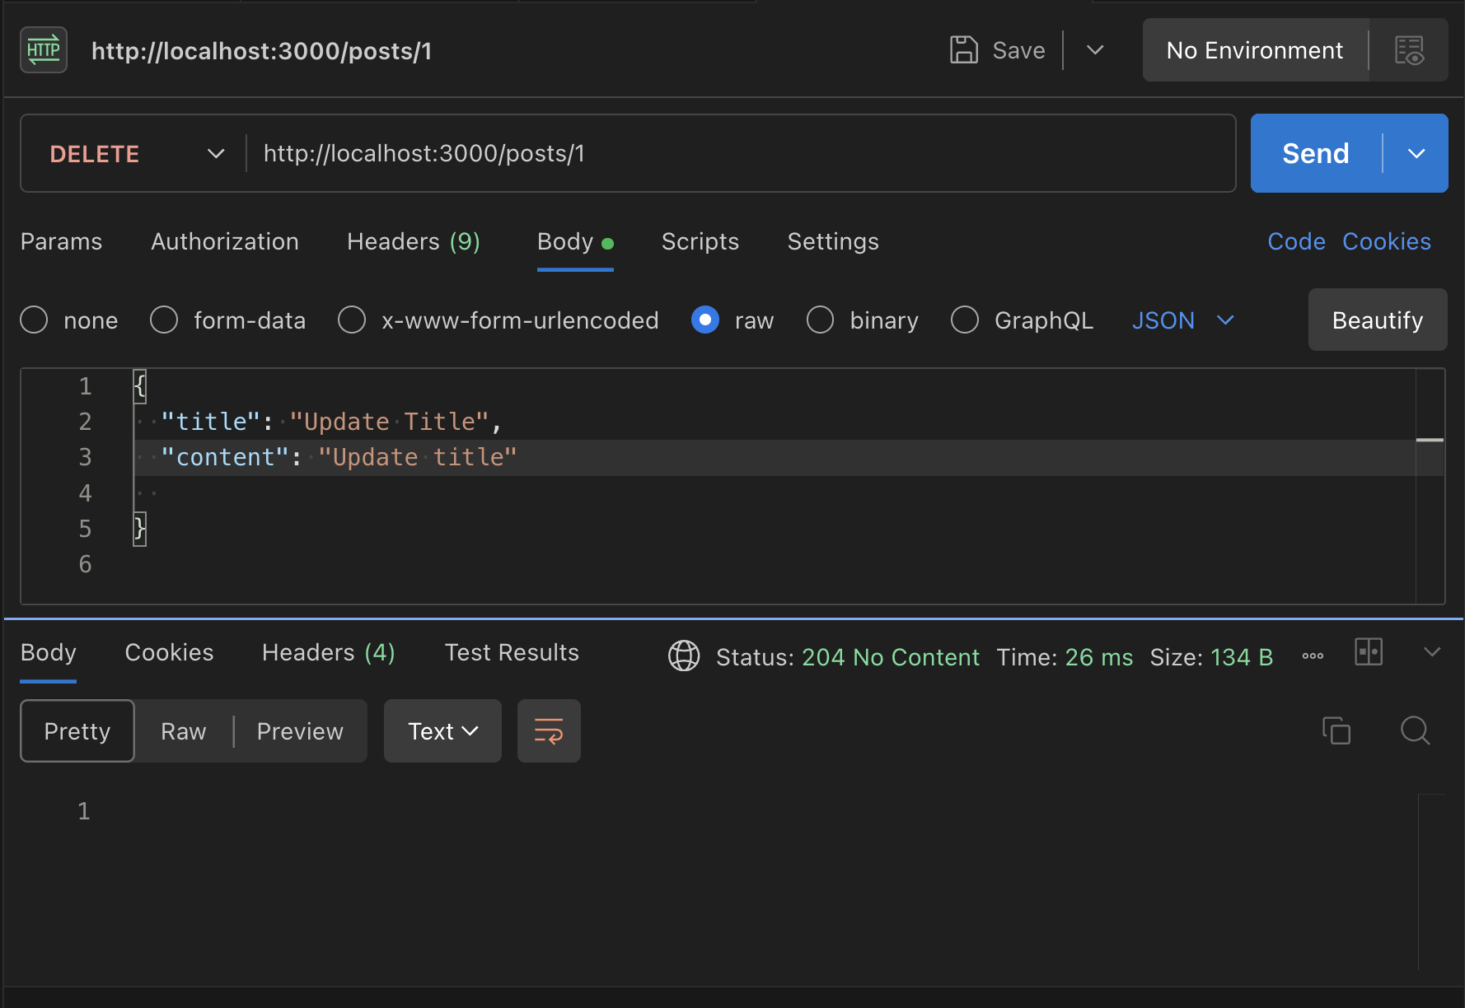

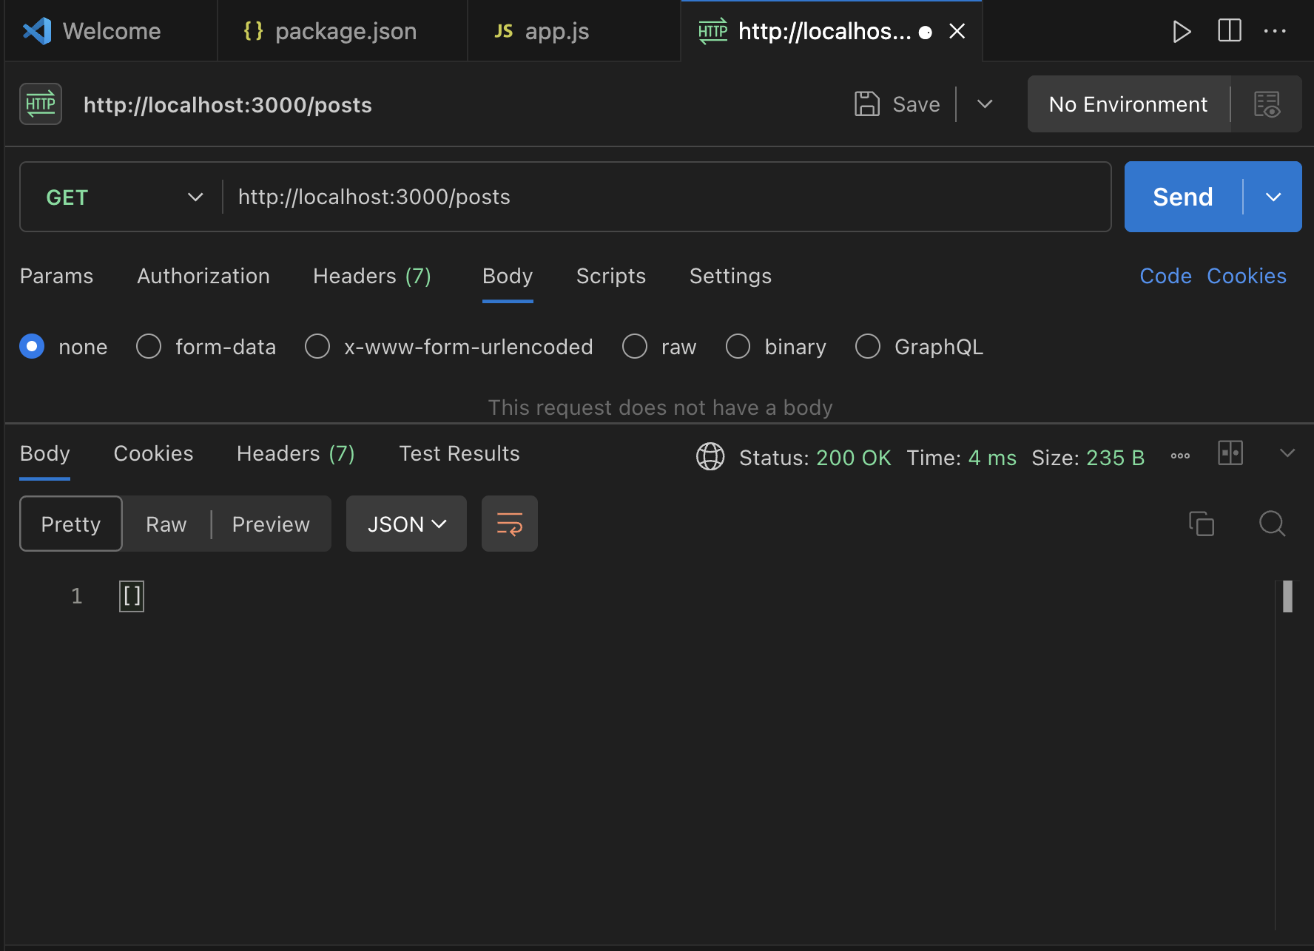

**MICROSERVICES**

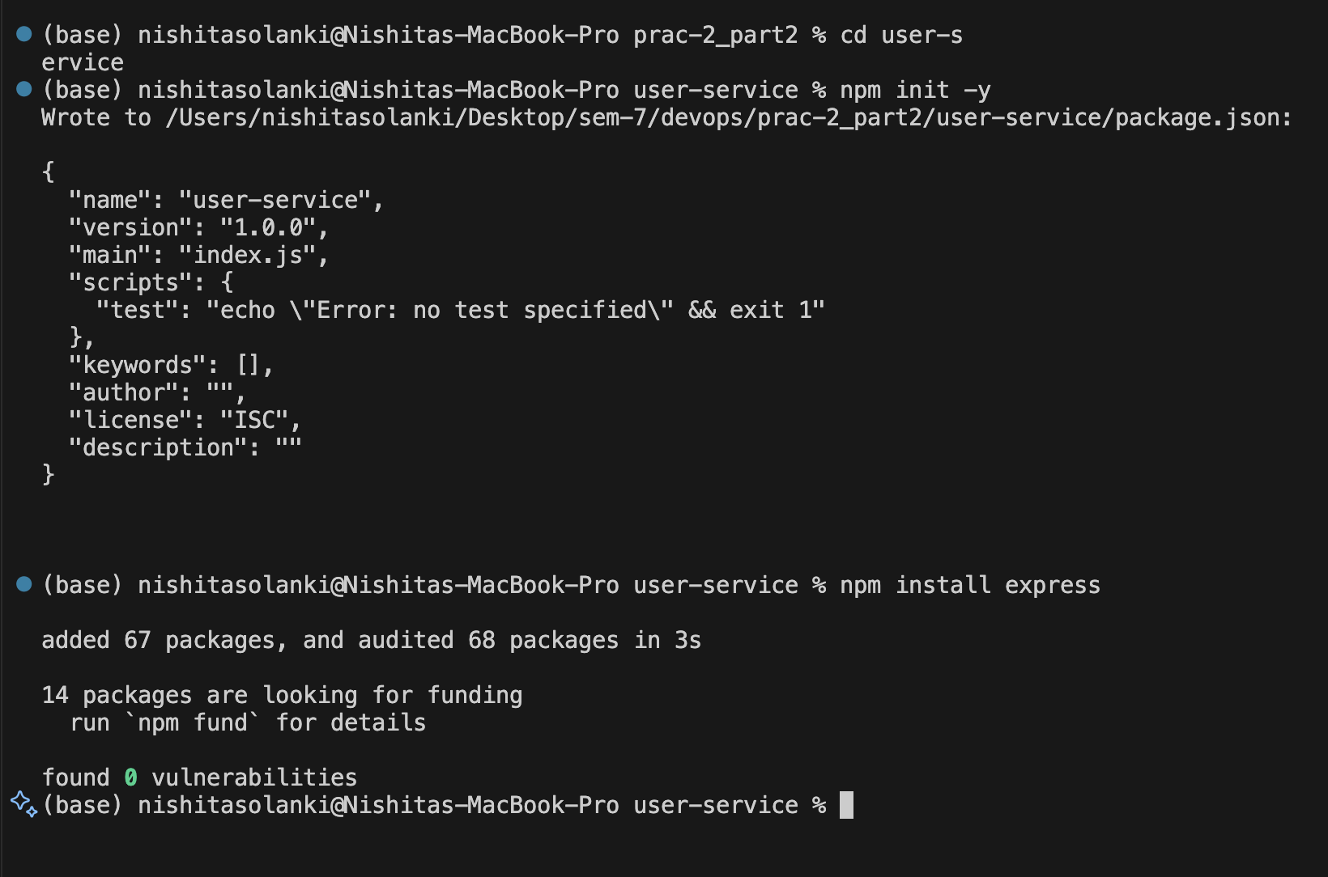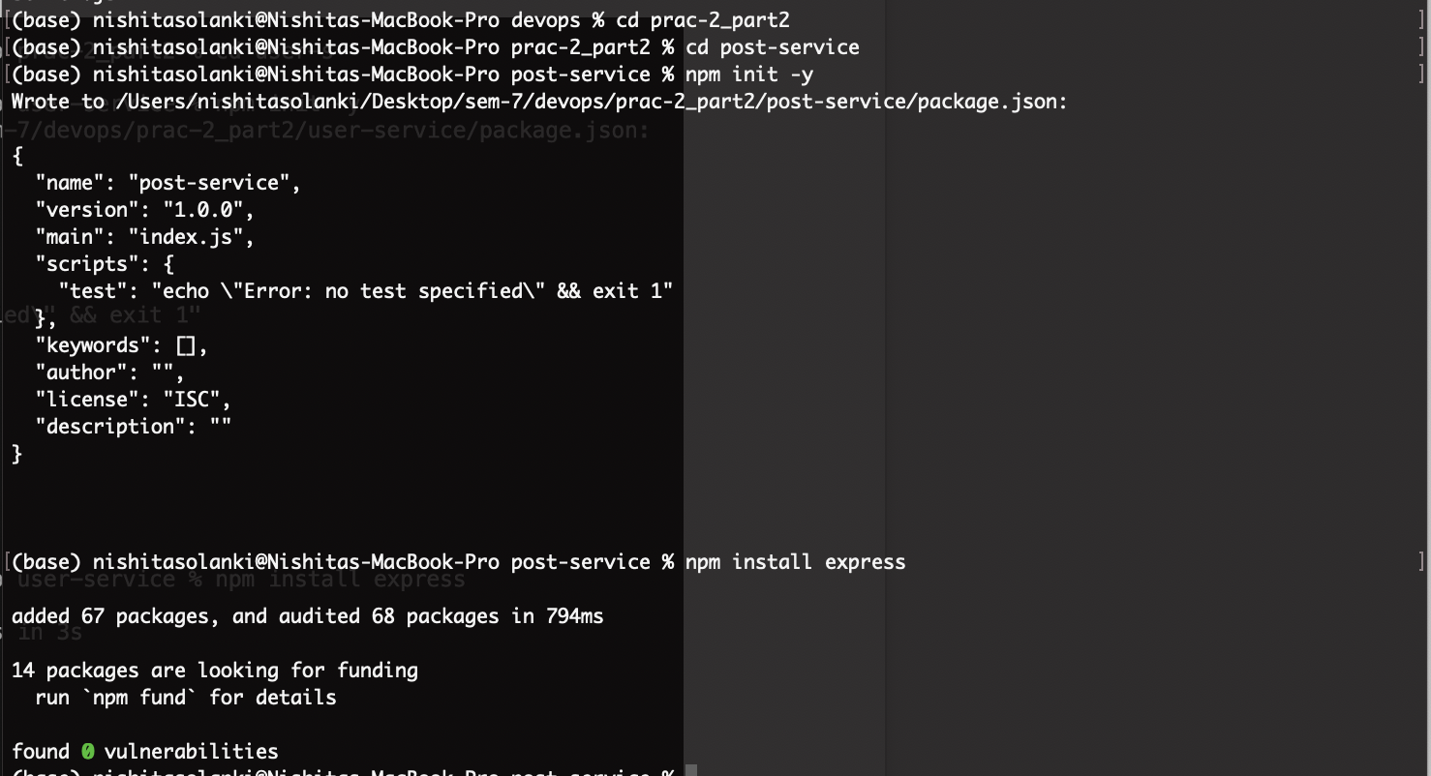

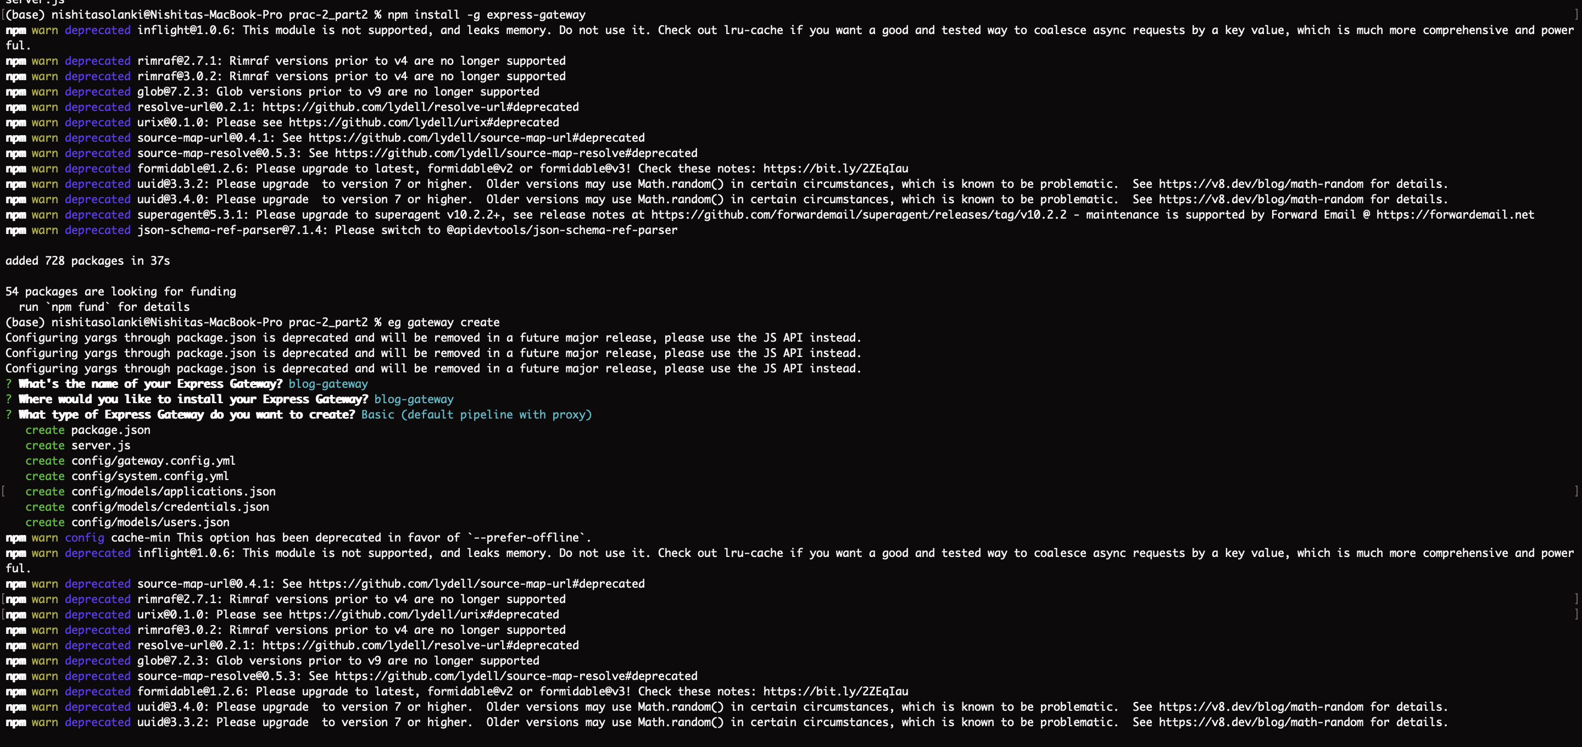

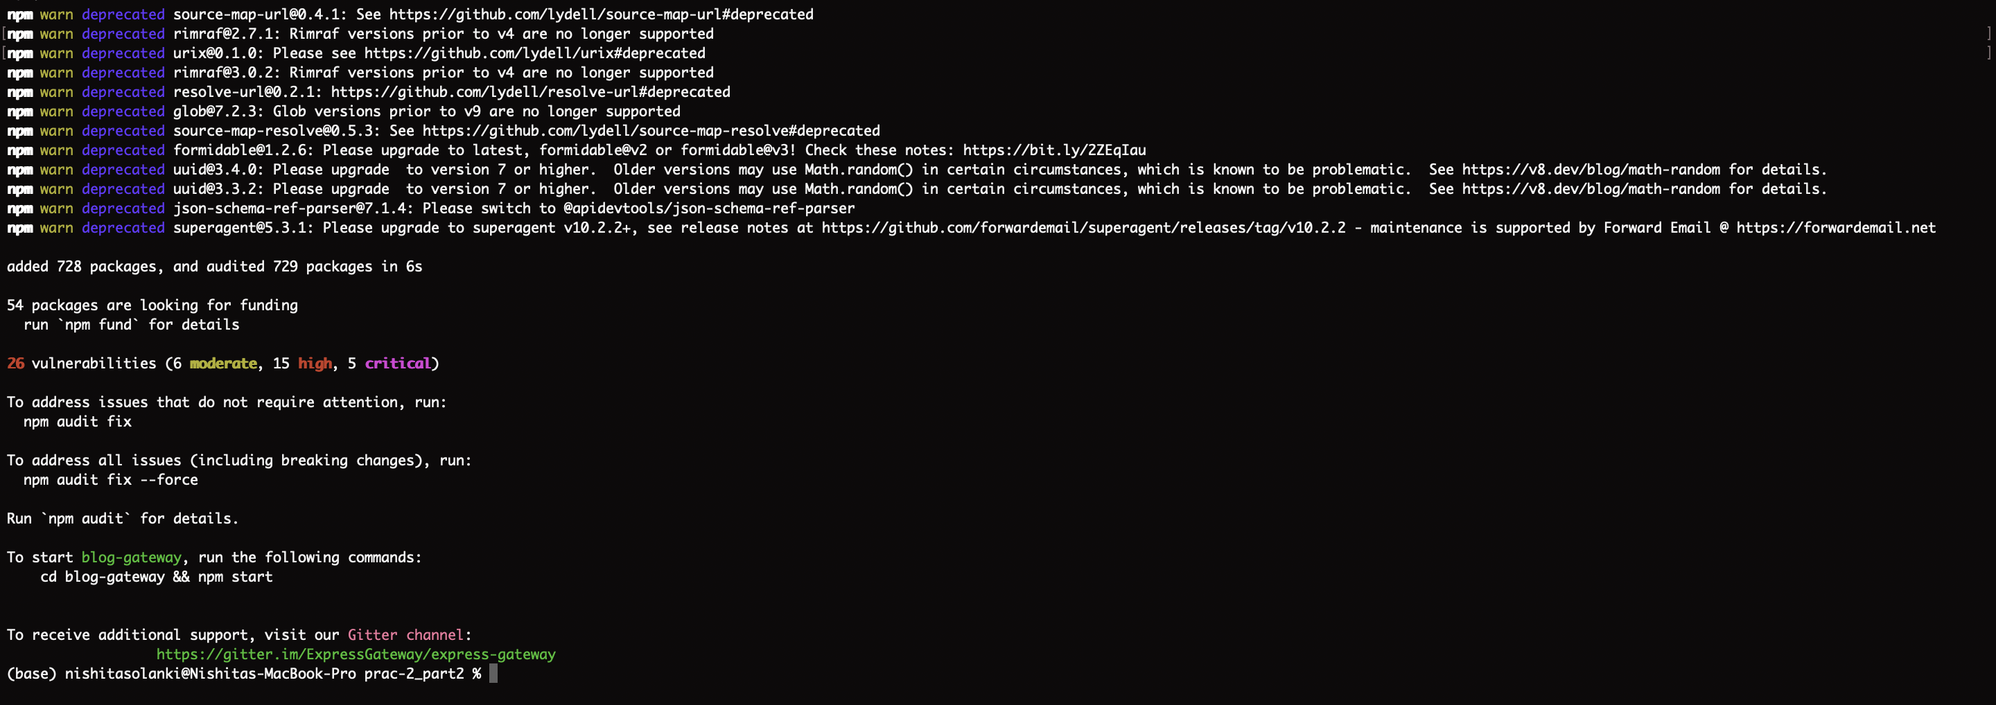

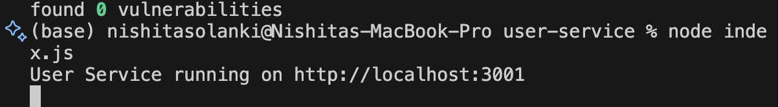

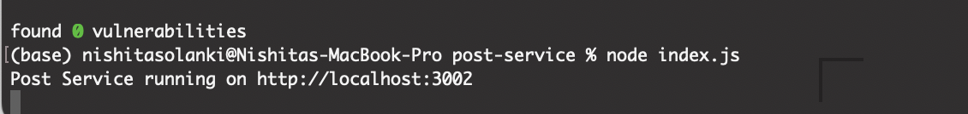

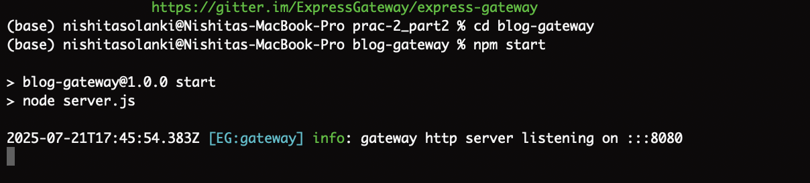

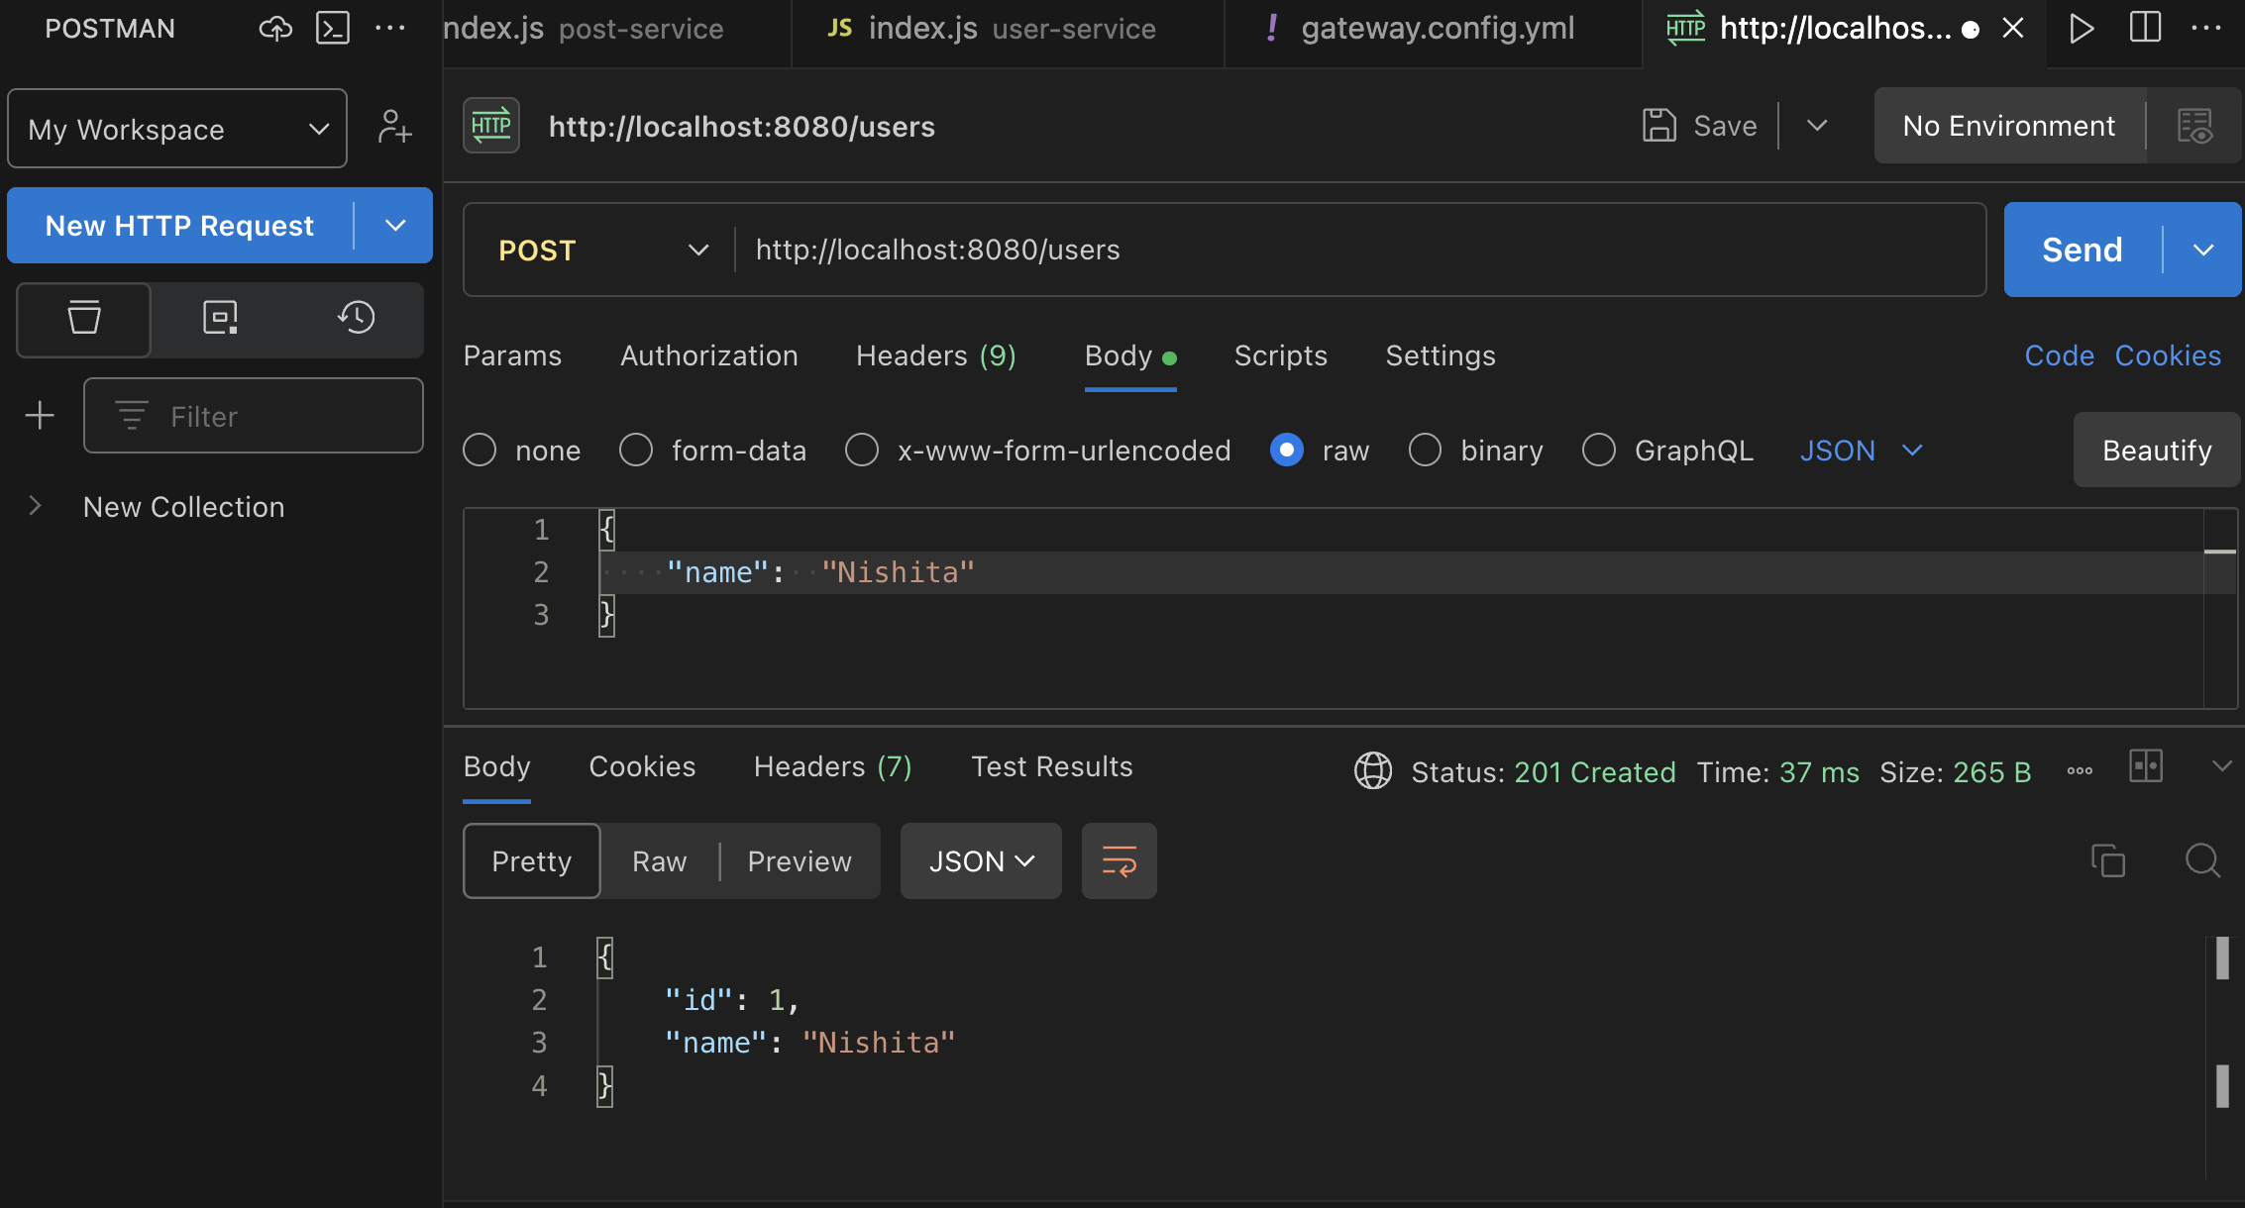

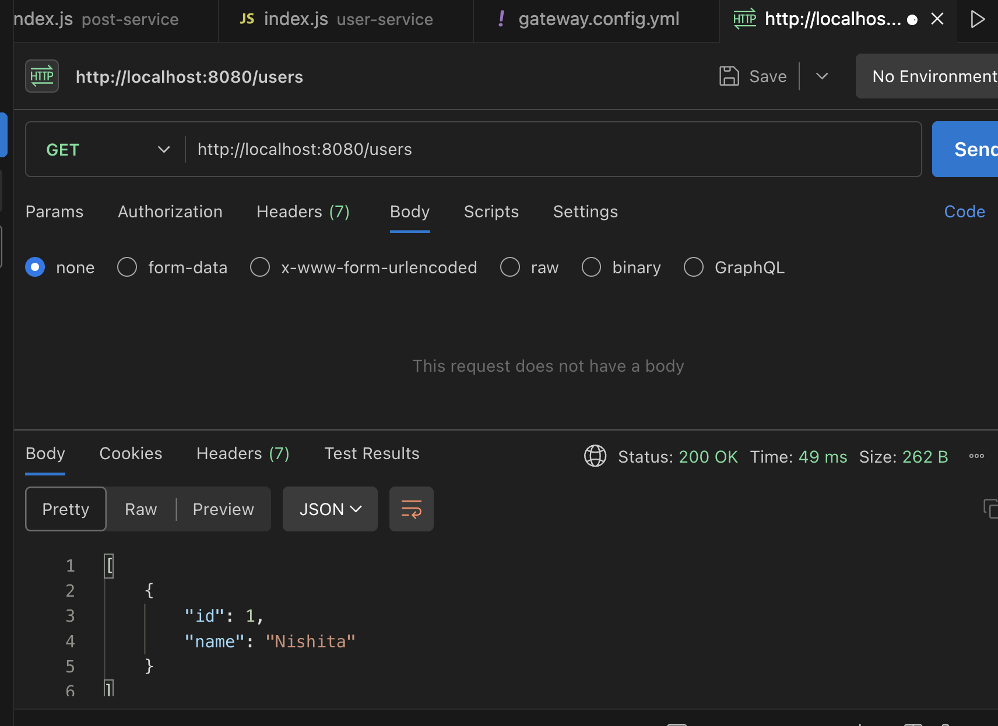

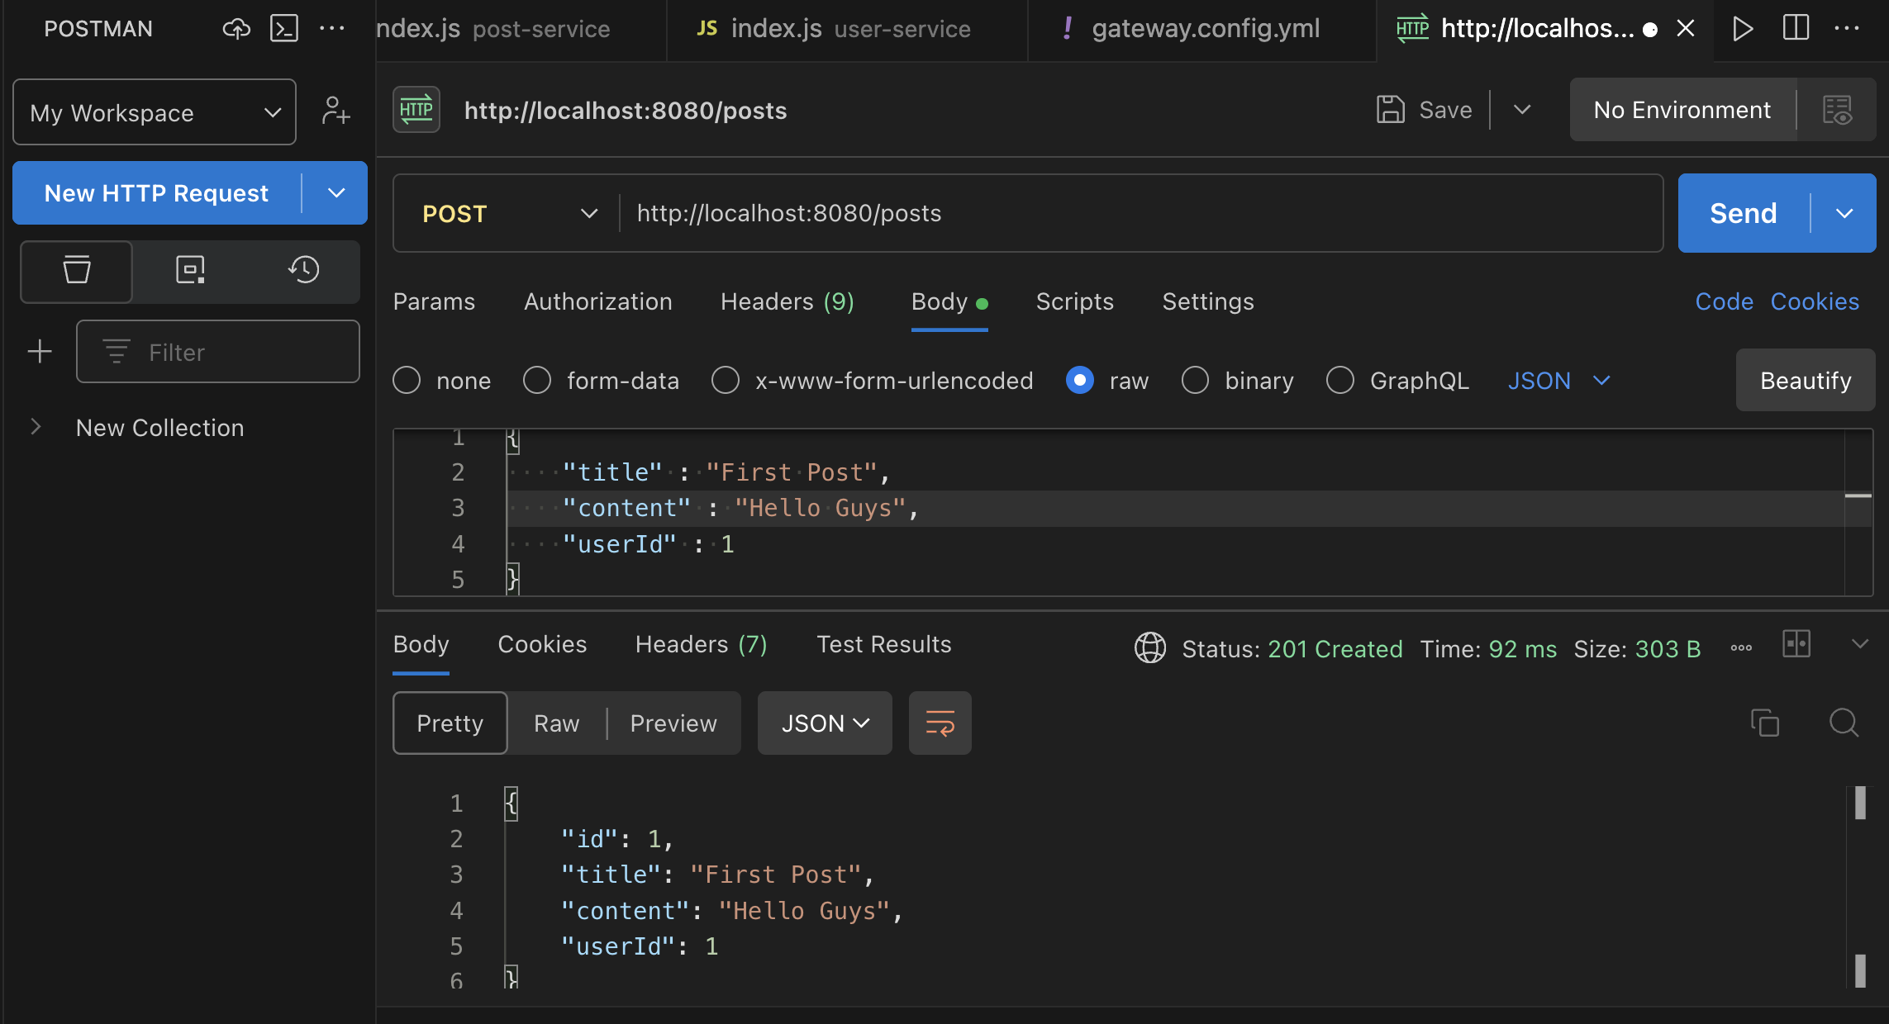

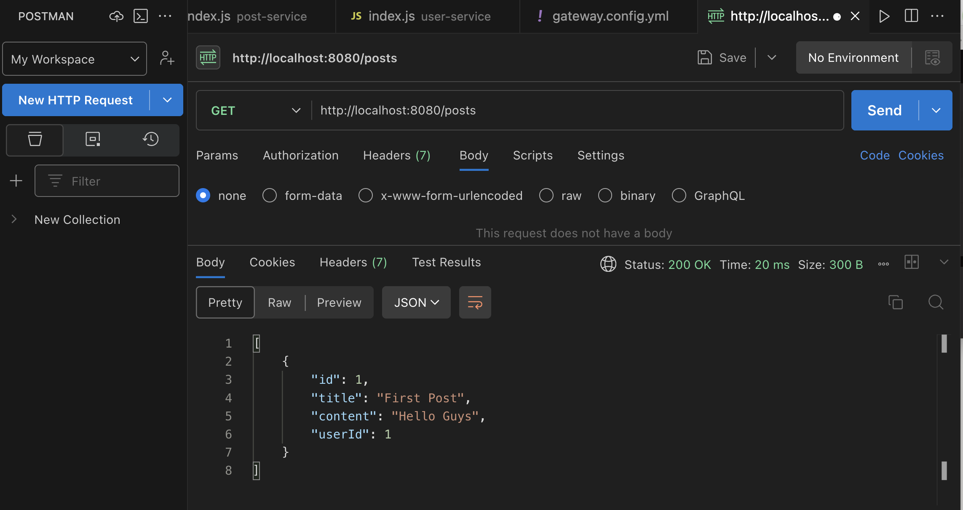

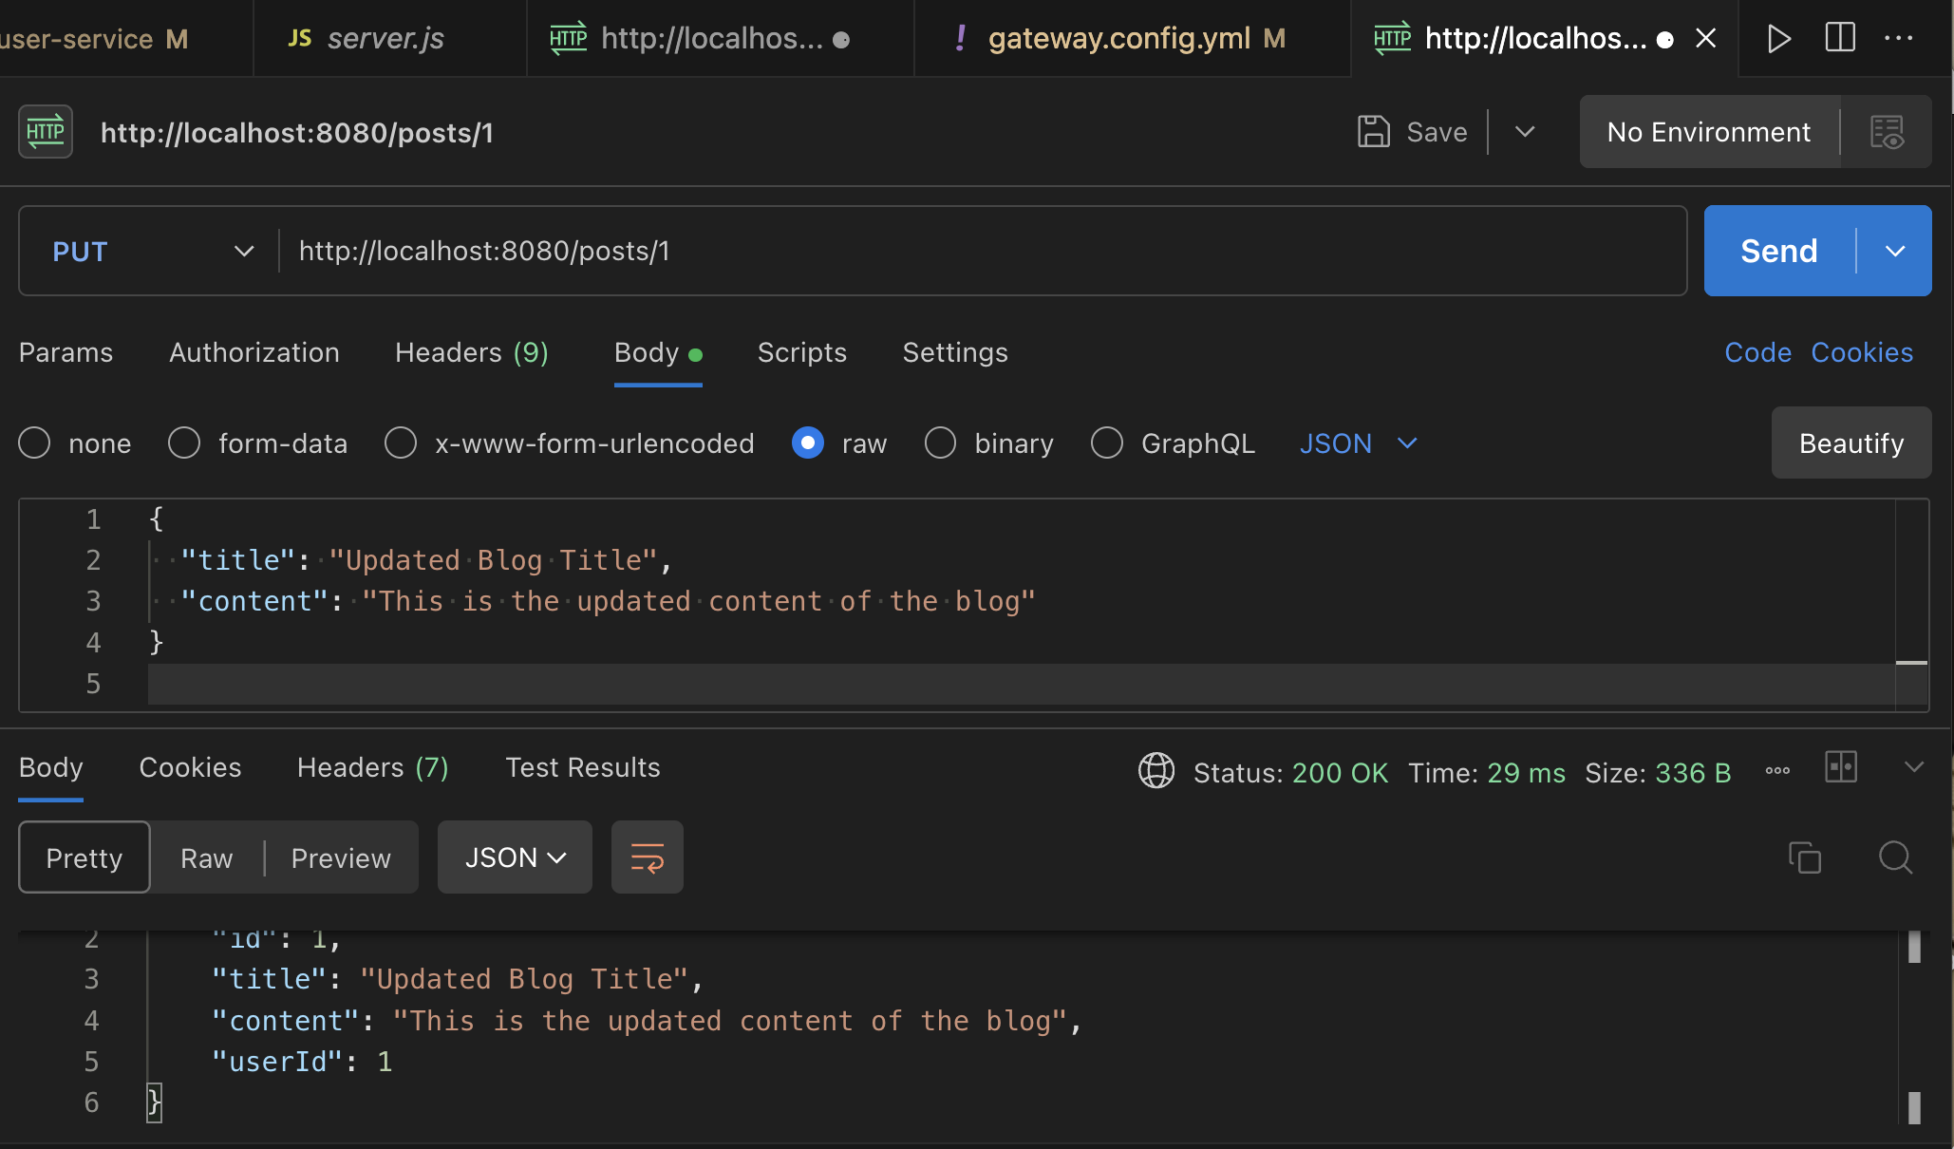

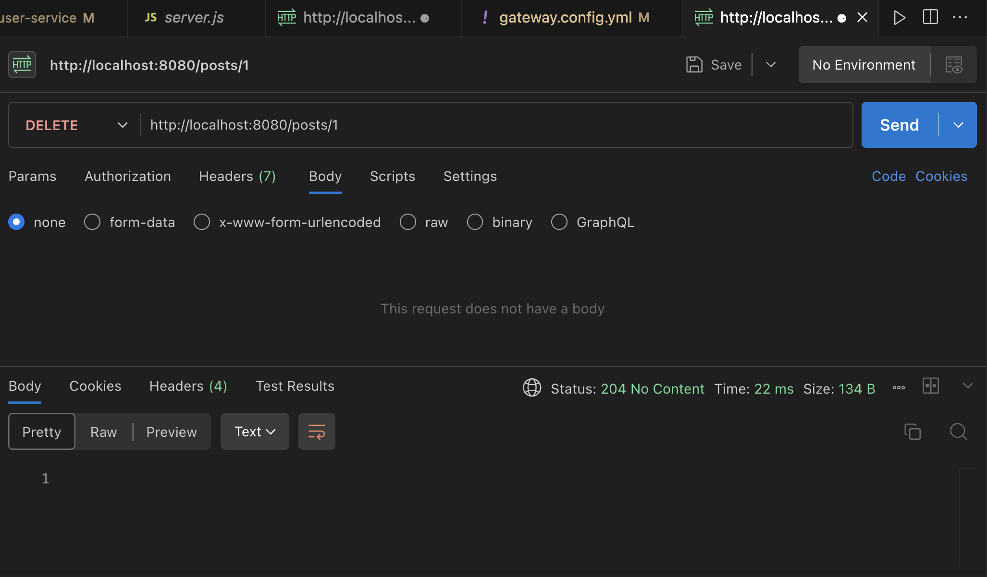

Checking

